 |  | 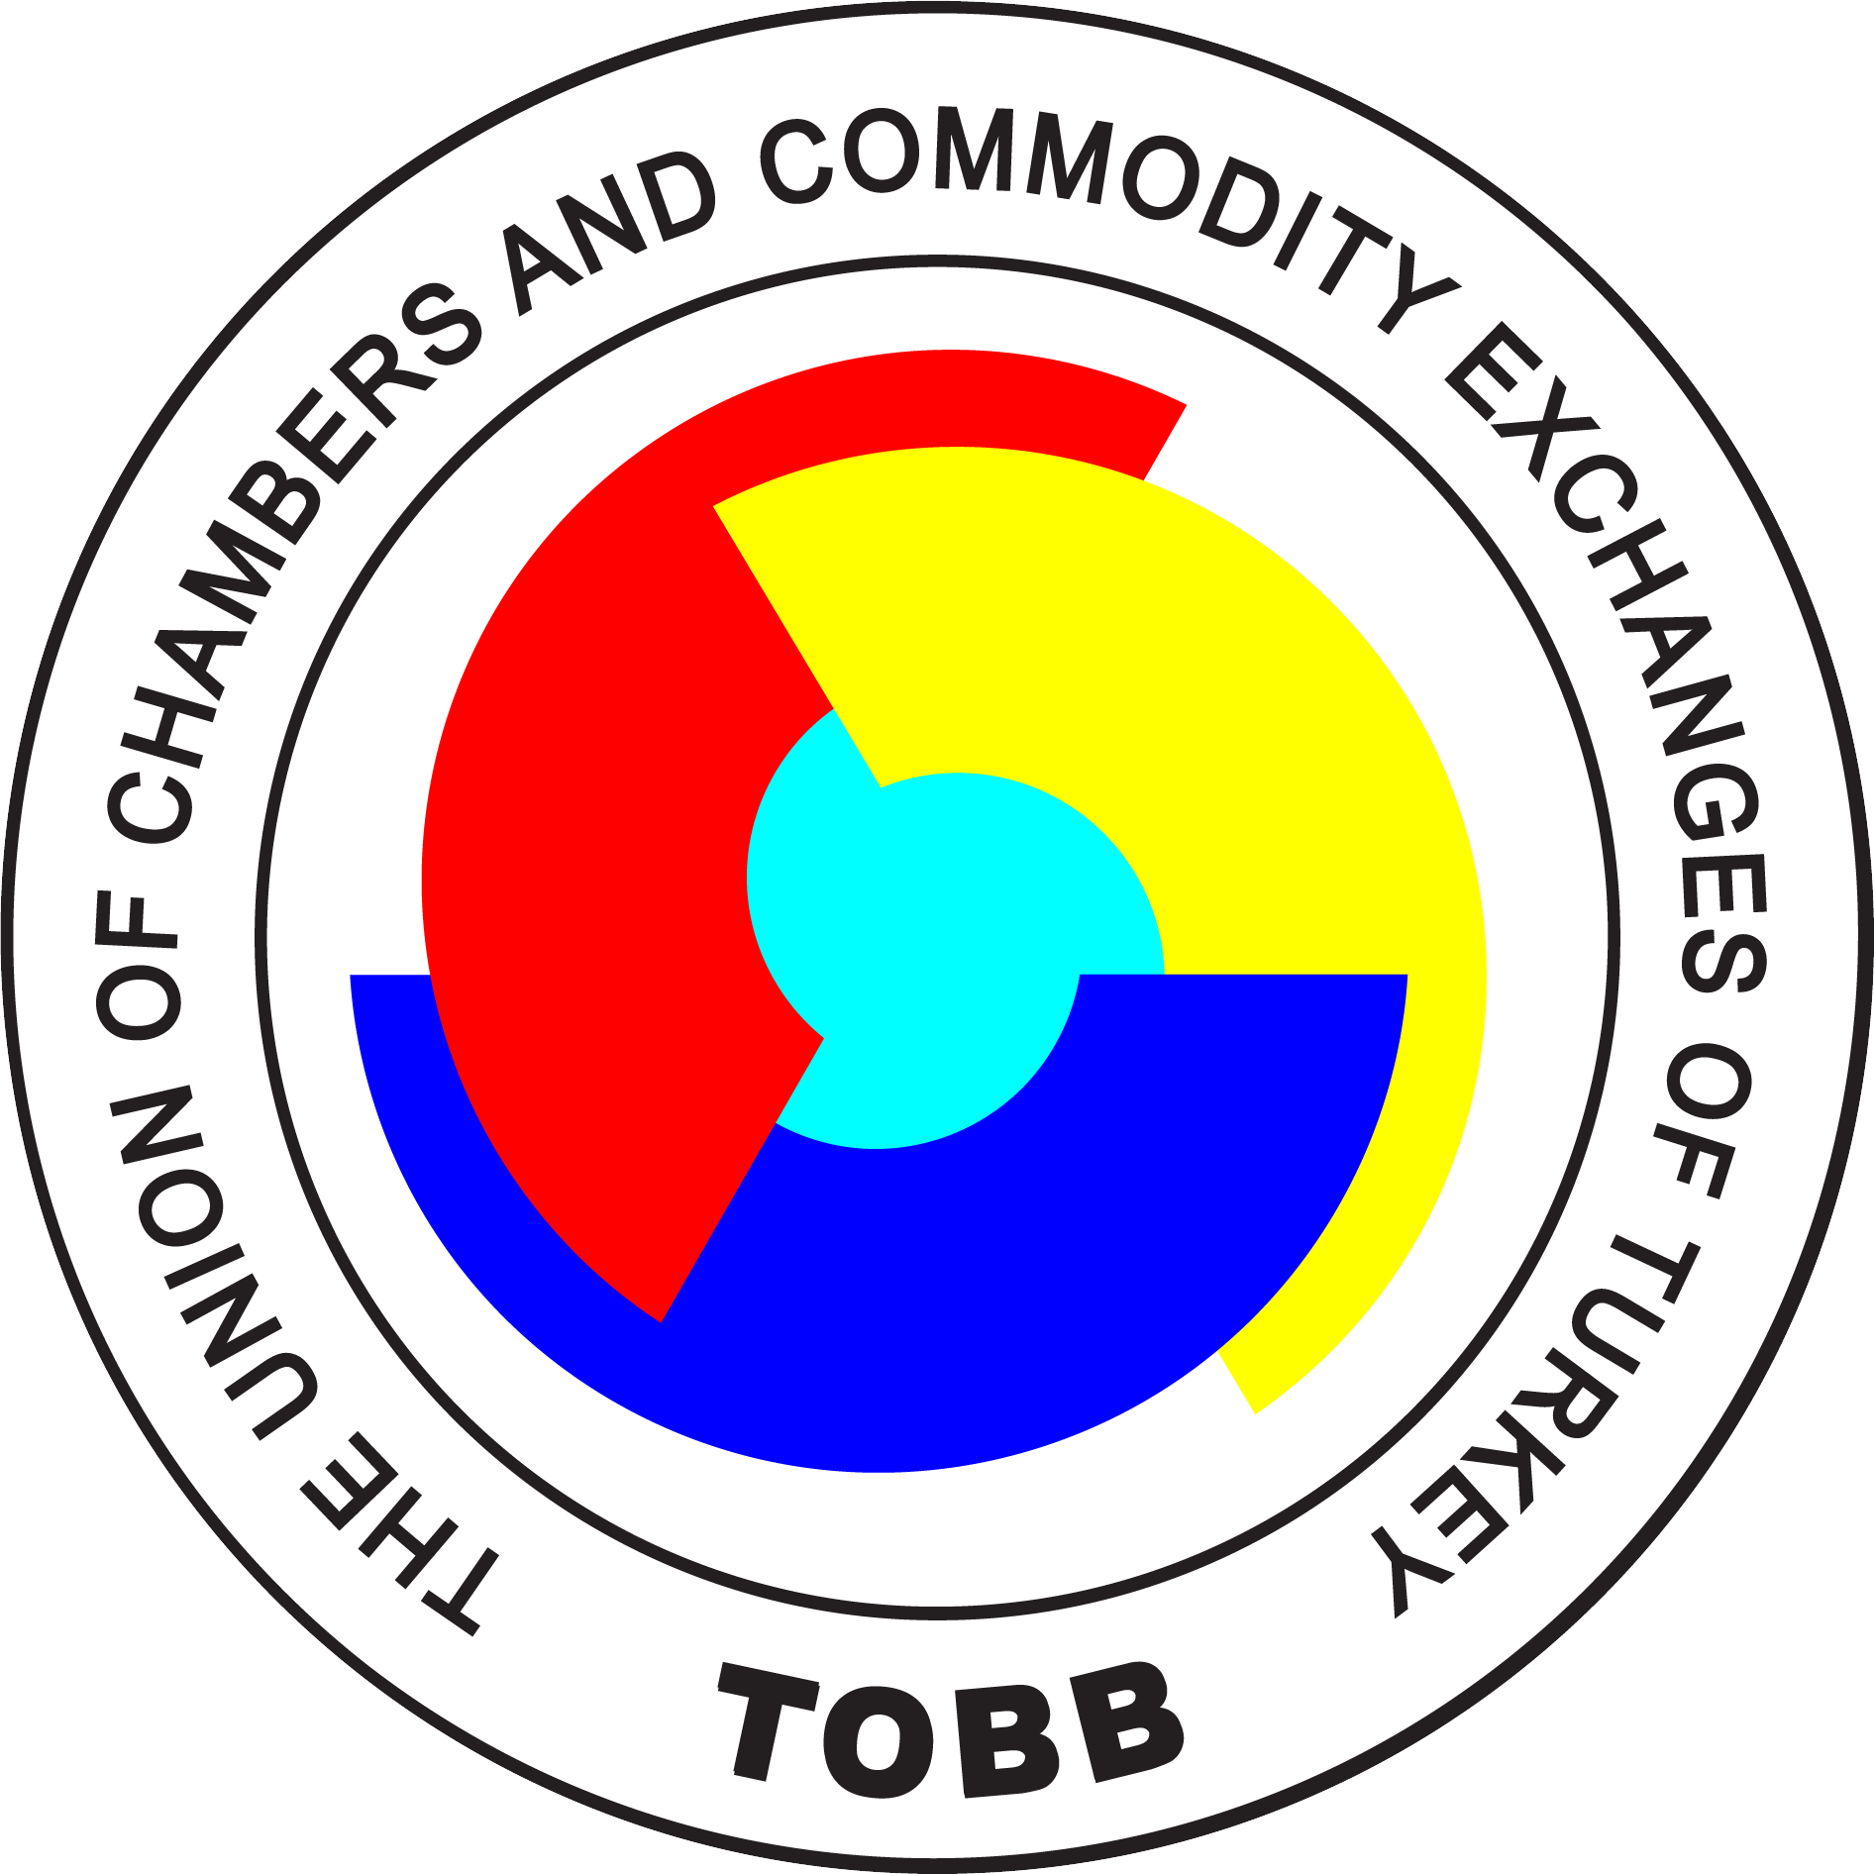
TURKISH-CANADIAN BUSINESS FORUM
ANKARA,11 OCTOBER 2017
DRAFT AGENDA
10:30 – 13:00 | TURKISH-CANADIAN BUSINESS FORUM: HOW TO GO FORWARD
Invitees:
- Ministry of Economy
- Ministry of Foreign Affairs
- Ministry of Energy and Natural Resources
- Ministry of Customs and Trade
- Ministry of Food, Agriculture and Livestock
- ISPAT
- Turkish Wealth Fund
- Canadian Embassy
- Canadian Companies
- Turkish Sectoral Assembly Representatives: (Mining and minerals, Construction Energy-renewable energy, Venture Capital, Telecommunication, etc.)
- TOBB ETU, METU
- TEPAV
Venue: TOBB Headquarters
Dumlupinar Bulvari No:252 Çankaya – Ankara Gate:3-4
10:30 – 10:45 | - Welcome remarks by TOBB  - Opening remarks by Mike Ward, Head of Canadian Business Mission to Turkey
10:45 – 11:30 | Investment Climate and Investment Opportunities of Turkey  - Economic Policy Research Foundation of Turkey (TEPAV)  - Ministry of Economy  - Investment Support and Promotion Agency of Turkey (ISPAT)  - Turkish Wealth Fund
11:30– 12:30 | Q & A
12.00 – 13:00 | Introduction of the Participants
13:00-14:30 | Networking Lunch and B2B  Venue: TOBB Headquarter
 | Ministerial Meetings (tbc- Mining, Infrastructure, Energy.)

