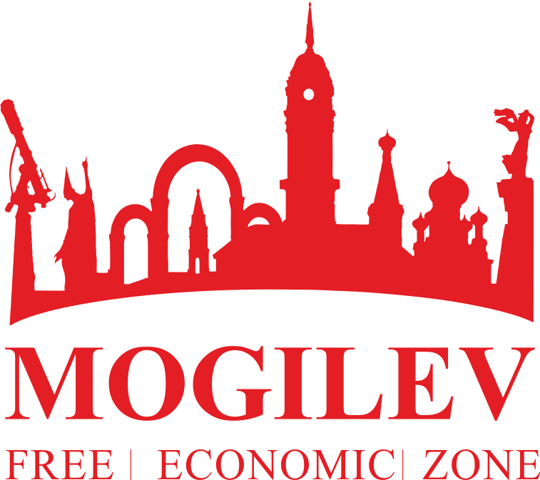
Participant Registration Form
INTERNATIONAL CONFERENCE ON WOODWORKING
& ANTHROPOGENIC IMPACT ON FOREST RESOURCES
Date and Venue of the Сonference: 14 – 15 September 2017, Mogilev city, Gorki city
Information about the company / organization:
Company name:
Kind of activity:
Country:
Address: |  |  |  | Web site & E-mail:
Information about Participant 1:
☐ Mr. ☐ Ms. |  |  |  | Occupation:
Name: |  |  |  | Phone number:
Surname: |  |  |  | E-mail:
Information about Participant 2:
☐ Mr. ☐ Ms. |  |  |  | Occupation:
Name: |  |  |  | Phone number:
Surname: |  |  |  | E-mail:
Information about Participant 3:
☐ Mr. ☐ Ms. |  |  |  | Occupation:
Name: |  |  |  | Phone number:
Surname: |  |  |  | E-mail:
Section for the Conference for participation:
☐ «WOODWORKING AS A BUSINESS»
☐ «WASTE MANAGEMENT & PROTECTION OF FOREST RESOURCES»
Do you plan to make a presentation?
☐ YES (at the plenary session) ☐ YES (at the section) ☐ NO
Topic:
Language:
Necessary technical equipment:
☐ Video projector  ☐ Video | Others (specify):
Do you need visa assistance:
☐ YES (please send the copy of your passport) |  |  |  | ☐ NO
Arrival and departure:
Date and time of arrival: |  |  |  | City of arrival:
Type of transport: |  |  |  | Flight number:
Date and time of departure: |  |  |  | City of departure:
Type of transport: |  |  |  | Flight number:
Accomodation:
☐ I need to book a hotel room ☐ I don’t need
Number of rooms: |  |  |  | Time period:
Any other wishes:
Attention, important information!
* According to the Presidential Decree “On establishment of visa-free entry and exit of foreign nationals”, foreign citizens of 80 countries can enter Belarus for up to 5 days and exit from the territory of Belarus only through the State border checkpoint of the Republic of Belarus “Minsk National Airport”
To enter the Republic of Belarus in the visa-free regime via the checkpoint “Minsk National Airport”, foreign nationals must have the following documents:
- a valid passport or another substituting document for traveling abroad;
- financial means: at least 25 Euro (or equal amount in dollars or Belarusian rubles) for each day of stay;
- medical insurance with coverage for at least 10,000 Euros that covers the territory of Belarus.
Details on http://mfa.gov.by/en/visa/visafreetravel/e0ced19bb1f9bf2c.html
** "Mogilev" Free economic zone administration will provide transfer of groups on the route "Minsk" National Airport – Mogilev city" on September 13, 2017 and back transfer on the route "Mogilev city – National Airport "Minsk" on September 16, 2017
*** Participation in the Conference is free of charge. Transportation costs (arrival in the Republic of Belarus / return departure) and accommodation are paid by the Conference participants.
CONFERENCE PARTICIPANT REGISTRATION PROCEDURE:
Send completed registration form before 01 September 2017
on E-mail: ewcm@yandex.ru or fax number: +375 222 31-15-81
Contact details:
Kiryl Khait - Head of department for investments and foreign economic affairs
Tel.: +375 222 31-19-81, Mobile phone: +375 29 313-84-30, +375 33 690-13-14
Sergey Mirankov - Deputy head of department for investments and foreign economic affairs
Tel.: +375 222 31-19-81, Mobile phone: +375 44 775-83-43, +375 29 742-66-38

