2017 Taipei Cycle Demo Day
- Date: March, 21st 2017, 9a.m. to 5p.m.
- Venue: Taipei Hua Zhung Campsite (Hua-Zhung Riverside Park, Wan-da Rd., Wan-hua Dist., Taipei City)
- Organiser: Taiwan External Trade Development Council;
Taiwan Bicycle Association
- Event Information:
(1) How to join:
A. Buyers can claim the test ride wristband at the entrance with the finishing page of Pre-registration for Taipei Cycle.
B. Application forms will be provided on site. Buyers can fill out the form along with one business card to get the wristband.
(2) How to get there:
A. Public Transportation: Take Blue Line to Longshan Temple Station. Choose one of the following bus lines to the designated stop sign.
62  49  601  673  260  38 | Longshan Temple-Dong Yuan (Hua Zhung Campsite )  Longshan Temple-Dong Yuan (Hua Zhung Campsite )  Wanhua Railway Station -Dong Yuan (Hua Zhung Campsite )  Guilin Rd.-Dong Yuan (Hua Zhung Campsite )  TCUH, Heping Branch-Dong Yuan (Hua Zhung Campsite )  Longshan Temple-Dong Yuan (Hua Zhung Campsite )
B. Shuttle Bus: Shuttle buses will be provided at Nangang Exhibition Centre, TWTC and Longshan Temple MRT Station. Timetable will be released on Taipei Cycle official website (www.taipeicycle.com).
(3) Location:
A. Test Ride Area
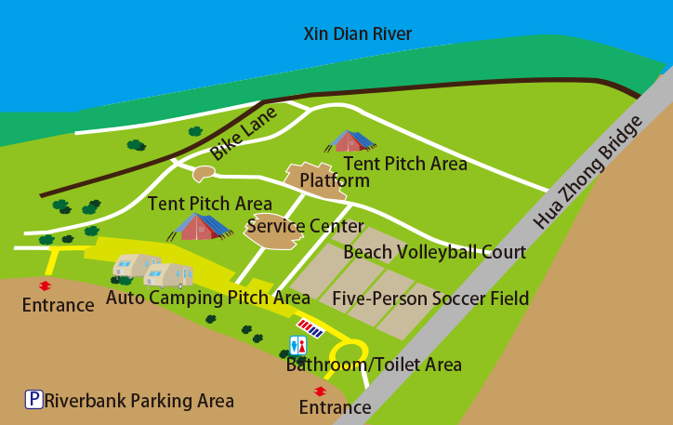
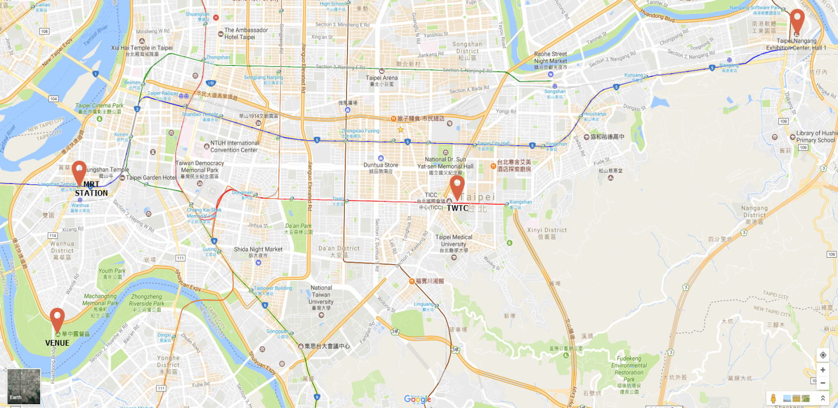
B. Pinpoint Map of the Show Halls, MRT Station and the Venue.

